SUPERSTORE ANALYSIS

Sales Performance Dashboard
This dashboard provides a comprehensive analysis of revenue, profitability, product performance, and regional trends. It highlights key financial metrics and identifies areas of strength as well as improvement opportunities to support data-driven decision-making.

Key Performance Highlights
- Total Revenue reflects steady sales performance across the selected period.
- Total Profit and Profit Margin indicate overall business health, with scope for margin optimization.
- Revenue contribution is concentrated among the top-performing products.
- Certain products generate lower profit, impacting overall margin efficiency.
- Regional analysis shows variation in performance, suggesting operational and pricing differences.
- Monthly sales trends reveal seasonal demand patterns.

Business Insights
- A small group of products drives a significant portion of total revenue.
- Low-margin or loss-making products require strategic review.
- Some regions perform strongly in revenue but show lower profitability.
- High-performing categories present growth expansion opportunities.

Strategic Recommendations
- Focus marketing and inventory planning on top-performing products.
- Optimize pricing and cost structures for underperforming items.
- Improve operational efficiency in low-margin regions.
- Leverage seasonal trends for promotional planning and demand forecasting.

Visualization
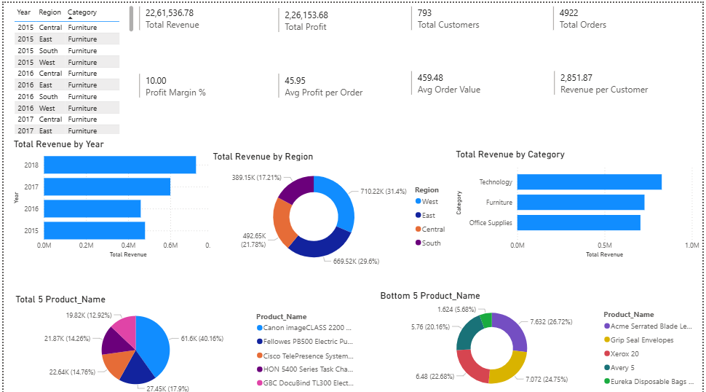

Conclusion
The dashboard enables clear visibility into financial and operational performance. By strengthening high-performing areas and addressing profitability gaps, the organization can improve overall margins and achieve sustainable growth.

